NIBRS Incident Report to Incident Reference IEP Conversion Utility

Utility Functionality Overview

Introduction

The purpose of this document is to describe the functionality of the NIBRS Incident Report to Incident Reference IEP Conversion Utility.

This utility has been developed as part of the SEARCH project to develop a Reference Information Exchange Package (IEP) for incident reporting. As part of that project, the utility provides an effective mechanism to test the robustness of the IEP, since the IEP should be capable of representing a NIBRS incident report. In fact, during development of the utility, a small number of missing IEP elements were discovered and incorporated into the final version of the IEP.

The utility is also a potentially valuable tool (or at least a solid basis for development of a tool) that could be incorporated into NIBRS-compliant law enforcement records management systems (RMSes), should those systems wish to emit XML instance reports that are valid according to the IEP structure.

The utility is written in the Java programming language, and will run in any Java 2 Standard Edition (J2SE) environment, version 1.4.2 or above. The utility also relies on the open-source XMLBeans library (http://xmlbeans.apache.org), which is one of the more robust and widely-used XML-Java binding toolkits available. The utility’s “inner workings” are thoroughly tested by a suite of nearly three dozen automated tests that rely on real NIBRS incident report test data supplied by the Tennessee Bureau of Investigation. Prior to delivery to SEARCH, the utility has been used to convert approximately 15,000 Tennessee incidents into XML, without a single error.

All Java source code for the utility is being delivered to SEARCH, along with a script for the Ant build tool (the primary build management mechanism for Java development) that creates the working utility from source code.

Running the Utility

(To run the utility, a Java 2 Standard Edition runtime environment, version 1.4.2 or above, is required. It is recommended that the J2SE runtime from Sun Microsystems be used. It can be downloaded from http://java.sun.com.)

Unzip the utility distribution zip file (nibrs-iep-converter.zip) into any folder on your system. The zip file contains five files, all ending in the “.jar” extension (Java Archives.) Double-click on nibrs-iep-converter.jar. You will see a small screen that looks like this:
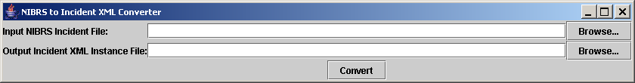

Use the “Browse…” buttons at the right to locate the input (NIBRS report) and output (XML) files (or you can type in the file paths if you know them.) Then click “Convert”. You will see a dialog pop up that looks like this:

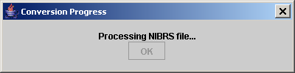

As incidents are being processed, the dialog will indicate how many incidents have been processed, and what each incident number is. At the end, a total number of incidents processed will be indicated, as follows:

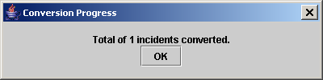

NIBRS to Incident IEP Mapping Notes

The following notes apply to the mapping of NIBRS report elements to Incident IEP schema elements:

- The utility only converts original submissions of Group A incidents. Group B incidents and updates/deletes of prior incidents are not converted.
- In general, the utility does not validate whether the NIBRS report file is valid. If the NIBRS report file contains invalid data, it is likely that the output XML instance will contain the same invalid data. (The utility, however, will not output invalid XML.)
- According to the NIBRS specification, if an offender is arrested, then some of the person’s information is duplicated on the Offender and Arrestee segments. The utility has no way of establishing that this information does in fact represent the same person. So, the utility will output separate subjects (one of whom will be associated with an arrest.) This remains true to the information reported via NIBRS. A stylesheet could be used to transform the output XML in a way that removes this duplication (by assuming identical information means the same person.)
- For Arrestees and Offenders, since NIBRS only allows submission of age value in years, the age measure unit attribute is omitted. It is included for victims (for whom NIBRS allows age values in days).
- The NIBRS race element is mapped to GJXDM’s PersonRaceCode element, even though that element’s enumeration comes from NCIC. The values in the NIBRS and NCIC codelists for race are identical.
- NIBRS interpersonal relationships that map to person relationship elements in GJXDM are mapped to those elements. NIBRS interpersonal relationships that do not map to GJXDM are represented using the PersonRelationship structure in the IEP.
- NIBRS property value is mapped to the GJXDM/IEP element “PropertyMissingValue.”
- The IEP generates XML ids for elements that can be the object of a reference (via IDREF). The generated ids are sequential and have no business meaning.
- Offenders, Arrestees, and Victims appear within an IncidentReport in the order dictated by their “sequence number” NIBRS elements. The sequence numbers themselves are not mapped into the XML.

The utility is also a good illustration of using XML-object binding in general—and XMLBeans in particular—with GJXDM.
If you intend to process large NIBRS incident files (e.g., over 5,000 incidents), you will need to increase the memory available to the utility. To do this, open a command prompt, navigate to the directory where the utility is installed, and type (without the quotes) “java –Xmx256M –jar nibrs-iep-converter.jar”. If you continue to have problems, either split up the NIBRS file into smaller pieces, or continue increasing memory by increasing the 256 number in the command to something larger, like 512M or 1024M.

